UDK: 004.942:519.876.5
¹PUTO A., ^{1,2}BUN R.
¹Lviv Polytechnic National University (Ukraine),
²WSB University (Poland)

Spatial modeling of greenhouse gas emissions from road transport in Ukraine

The greenhouse gas emissions caused by road transport are the highest in the transport sector. Therefore, it is necessary to develop methods to reduce these emissions and mitigate the effects of climate change. This study presents spatial modeling of greenhouse gas emissions in the road transport sector in Ukraine, at both the level of separate road segments and the regional level. The results include emissions of carbon dioxide, methane, nitrous oxide, nitrogen oxides, carbon monoxide, non-methane volatile organic compounds, and sulfur dioxide for the period from 2015 to 2022.

According to the Kyoto Protocol, an international agreement between countries to avoid global warming, Ukraine must report on the GHG emissions from different economic sectors each year. A large share of them is caused by the transport sector, especially the road sector [1]. The aggregated emission data at the national scale do not provide the necessary support for decision-making to reduce emissions at the regional or local levels. This study aims to develop a spatial inventory of GHG (CO₂, CH₄, N₂O, NO_{x}, CO, NMVOC, and SO₂) emissions in the road transport sector (1A3b according to IPCC Guidelines).
Using OpenStreetMap data, a map of road routes was created, and the following information was collected for each road segment: its length, type, and working condition. The number of transport units per day that passed through the road segment was defined using [2], along with information about the road type and its category. We utilized the DeepStateMap resource [3] to examine the road network occupied during the 2022 war, analyzing the territories affected during this period.
In accordance with the Kyoto Protocol, road transport is categorized into the following types: cars, light-duty trucks, heavy-duty trucks, buses, and motorcycles. The amount of GHG emissions depends on fuel consumption by these types of transport. These fuels are gasoline, diesel oil, liquefied petroleum gases (LPG), and other liquid fuels. Ukraine publishes these data in the national inventory reports each year [4]. For the distribution of fuel consumption, we collected information about the number of petrol stations in every region of Ukraine [5].
By road category (motorway, trunk, primary, secondary, tertiary, unclassified, residential) for each segment, we assigned the traffic intensity coefficient and the condition coefficient of the segment (equal to 1 if used or 0 if not). For occupied roads in 2022, we calculated the coefficient, which depends on the number of months of occupation. A total of 788,732 road segments were analyzed.
To distribute g-th greenhouse gas emissions ($g∈${CO₂, CH₄, N₂O, NO_{X}, CO, NMVOC, SO₂}) caused by f-th type of fuel ($f∈${gasoline, diesel oil, liquefied petroleum gases (LPG), other liquid fuels}) for each n-th road segment, which is located in the r-th region of Ukraine, we used the following model:
$E_{rd,f,n,t,r}^{(g)}={EF}_{rd,f}^{(g)}∙\frac{P_{r}}{\sum_{R}{P_{r}}}∙\frac{l_{rd, n}∙k_{rd,cond,n}∙k_{rd,int,c}∙k_{rd,occ,n}}{\sum_{n∈r}{l_{rd, n}∙k_{rd,cond,n}∙k_{rd,int,c}∙k_{rd,occ,n}}} ∙{AD}_{t,f}$,
where $E_{rd,n,t,f,r}^{(g)}$are the emissions of the g-th greenhouse gas caused by f-th fuel on n-th segment of the road during t-th year; ${EF}_{rd,f}^{(g)}$is the emission factor for g-th gas from f-th fuel; $P_{r}$ is the number of petrol stations in r-th region (R is the set of all regions in Ukraine); $l_{rd, n}$is the length of n-th segment; $k_{rd,cond,n}$is the condition coefficient for the n-th segment (1, if the road segment is used, and 0, if not); $k_{rd,int,c}$ is the traffic intensity coefficient for $c_{rd, n}$-th type of road ($с∈${ motorway, trunk, primary, secondary, tertiary, unclassified, residential }); $k_{rd,occ,n}$ is the coefficient, which shows the number of months of occupation of the n-th segment; ${AD}_{t,f}$ is the national total of the f-th fuel used during the t-th year according to [4].
We also used the models:
$E_{rd,f,t}^{\left(g\right)}=\sum_{n=1}^{N}{\sum_{r=1}^{R}{E_{rd,f,n,t,r}^{\left(g\right)}}}$, $E_{rd,t}^{(g)}=\sum_{f=1}^{F}{E_{rd,f,t}^{(g)}}$, $E_{rd,t}=\sum_{g}{{GWP}^{\left(g\right)}}∙E_{rd,t}^{\left(g\right)}$
to calculate the total emissions of the g-th GHG caused by the f-th fuel, by all types of fuel, and the total emissions of all GHGs, accordingly, where ${GWP}^{(g)}$ are the global warming potentials of CO₂, CH₄, N₂O.
The results for carbon dioxide emissions at the level of administrative regions of Ukraine are presented in Fig. 1. From 2015 to 2022, the total emissions of CO₂, caused by all types of fuel, we estimated to be 186,987.4 kt, methane 66.39 kt, nitrous oxide 10.91 kt, nitrogen oxides 1,064.29 kt, carbon monoxide 3,067.87 kt, non-methane volatile organic compounds 521.6 kt, and sulfur dioxide 183.35 kt.
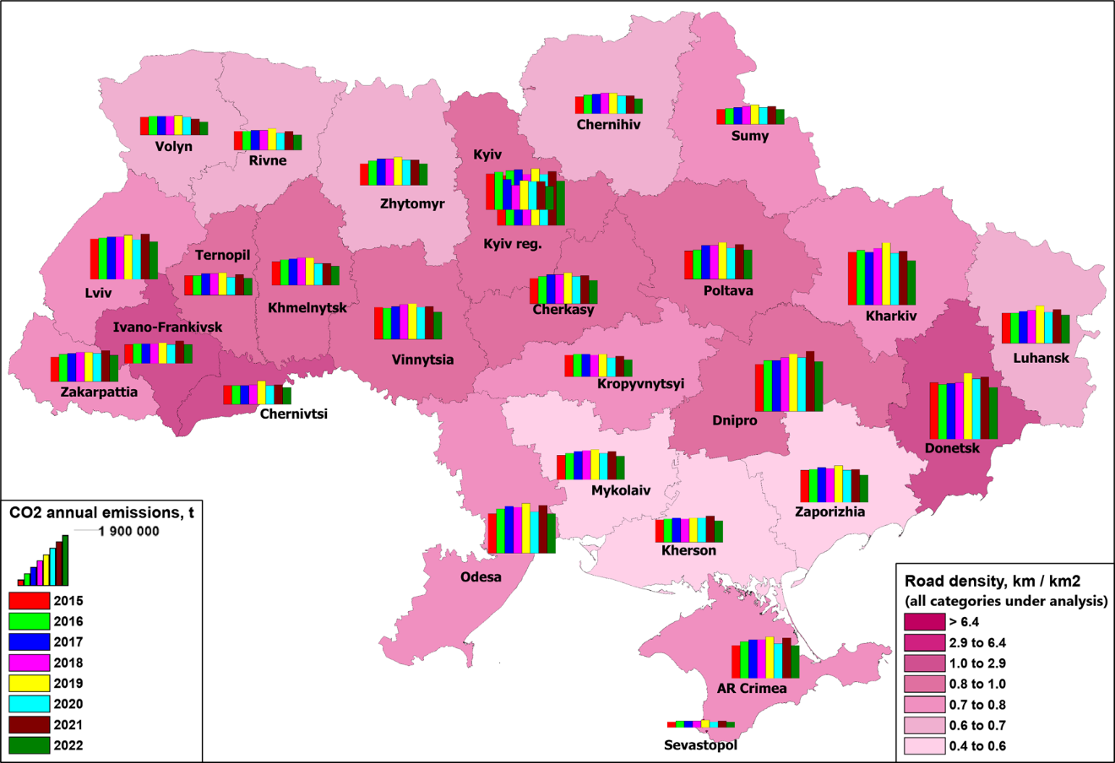
Fig. 1. Results of spatial modeling at the level of administrative regions: Emissions of carbon dioxide from road transportation in Ukraine.
It is essential to note that, due to the part of Ukraine's territory that has been occupied since 2014, the input data contains some uncertainty. Due to the lack of official statistical data for this territory, expert assessment was used in [4]. The results of the modeling indicate that GHG emissions from road transport are substantial, necessitating the development of methods to mitigate them. For example, this could include encouraging people to drive electric cars or improving bicycle infrastructure.

REFERENCES
1. Bun R., Boychuk Kh., Bun A., Lesiv M. Information technologies for spatial inventory of greenhouse gases in the energy sector and uncertainty analysis. Lviv: PP Soroka T., 2012. 464 p.
2. DBN V.2.3-4:2015. Automobile Roads. Part II. Construction. Kyiv: Ministry of Regional Development, Construction, Housing and Communal Services of Ukraine, 2015. 112 p.
3. DeepStateMap – Interactive map of military operations in Ukraine. [Online resource]. Available at: https://deepstatemap.live
4. UNFCCC. National Inventory Submissions 2024 – Greenhouse Gas Inventories for Annex I Parties. [Online resource]. Available at: https://unfccc.int/ghg-inventories-annex-i-parties/2024
5. State Statistics Service of Ukraine. Operational data: “The volume of wholesale and retail sales of light petroleum products and gas through gas stations by region”. [Online resource]. Available at: https://www.ukrstat.gov.ua/operativ/operativ2021/sr/prsv_az_m/arch_prsv_az_2021m_u.htm

